1. Try the “make” command. What happens? Use “ls” to inspect your directory.  
     
   Text

   Description automatically generated  
     
   The gcc command is typed out and a new executable file called “makefile” is created
2. 1. what is the output? Why is this happening?  
        
      NO ERROR
   2. 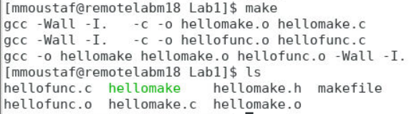  
        
      We have 2 new gcc commands (the first 2). This is to compile the hellomake.c and hellofunc.c because we need them compiled (because we need their object files) to run the final command.
3.  it says hellomake is up to date
4. A picture containing box and whisker chart

   Description automatically generated  
     
   Text

   Description automatically generated